**Activity Diagram:**

**Level 1.1:  
Name:** Registration & Login  
**Primary Actors:** User (Student, Teacher, Staff), Librarian  
**Secondary Actors:** OTP Generator, Email Generator

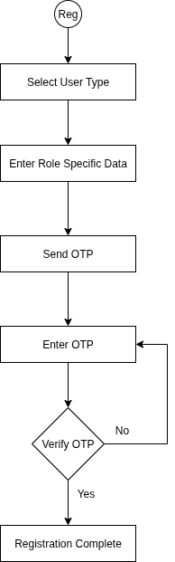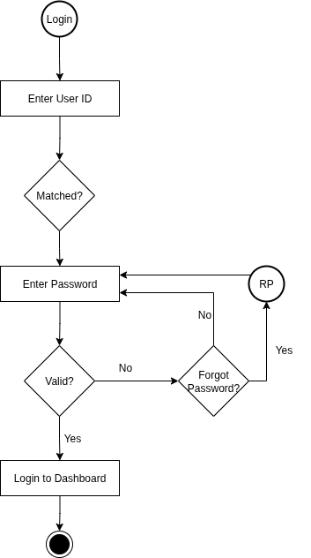

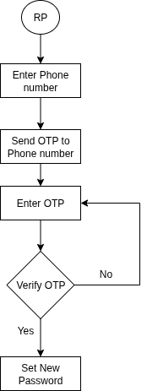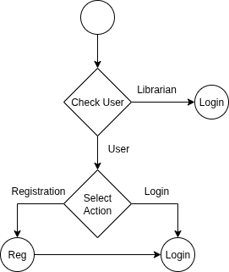

**Level:** 1.2  
**Name:** Dashboard  
**Primary Actor:** User (Student, Teacher, Staff), Librarian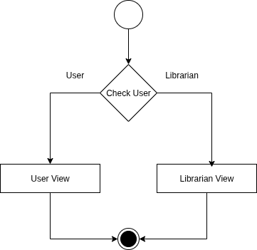

**Level:** 1.2.1  
**Name:** User View  
**Primary Actor:** User (Student, Teacher, Staff)

**Level:** 1.2.2  
**Name:** Librarian View  
**Primary Actor:** Librarian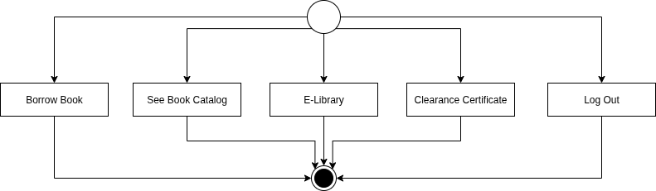

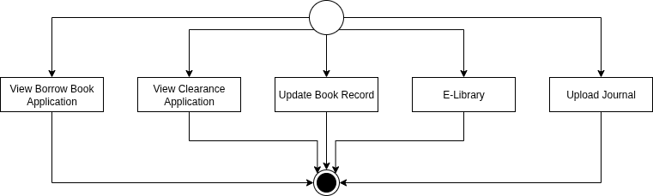

**Level:** 1.3  
**Name:** E-library  
**Primary Actor:** User (Student, Teacher, Staff), Librarian  
**Secondary Actor:** Summary Generator

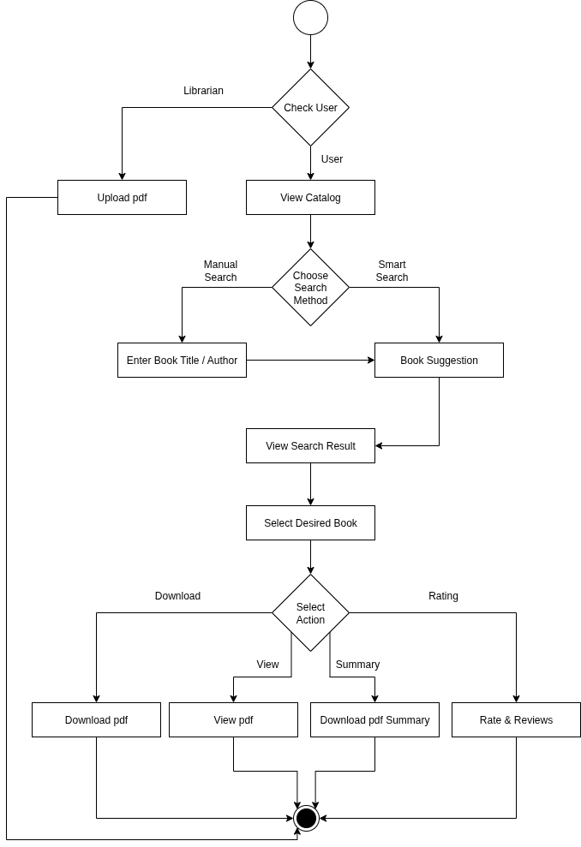

**Level:** 1.4 **Name:** Borrow Book  
**Primary Actor:** User (Student, Teacher, Staff)

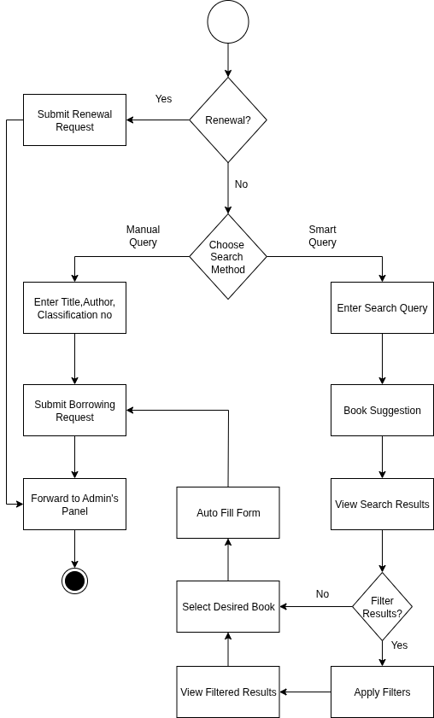

**Level:** 1.5  
**Name:** Approval  
**Primary Actor:**  User (Student, Teacher, Staff), Librarian  
**Secondary Actor:** Email Generator, MFS

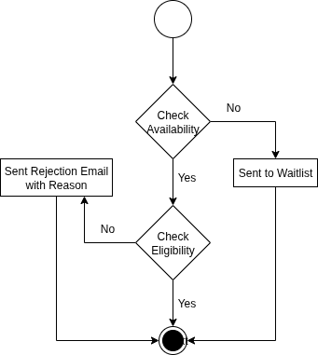

**Level:** 1.5.1  
**Name:** Availability  
**Primary Actor:** Librarian  
**Secondary Actor:** Email Generator

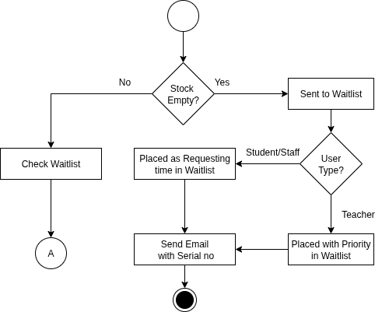

**Level:** 1.5.2  
**Name:** Eligibility   
**Primary Actor:** User (Student, Teacher, Staff), Librarian  
**Secondary Actor:** Email Generator, MFS

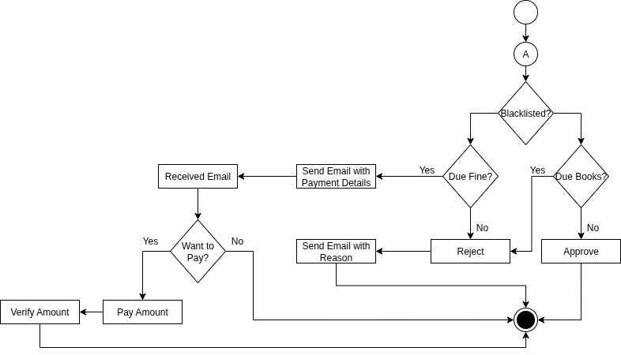

**Level:** 1.6  
**Name:** Clearance  
**Primary Actor:** User (Student, Teacher, Staff), Librarian  
**Secondary Actor:** Email Generator

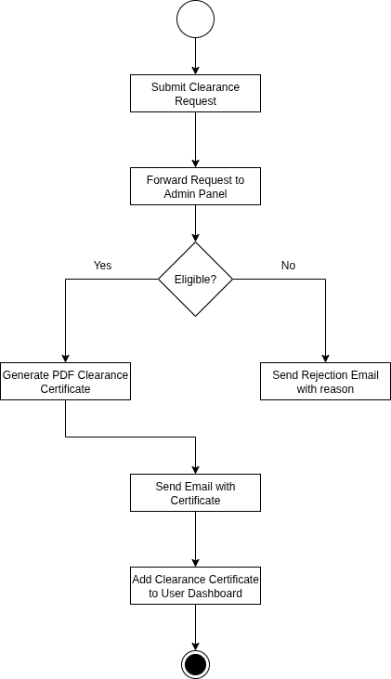

**Level:** 1.7  
**Name:** Update Book Record  
**Primary Actor:** Librarian, System  
**Secondary Actor:** BPC(Book Purchase Committee), Email Generator

